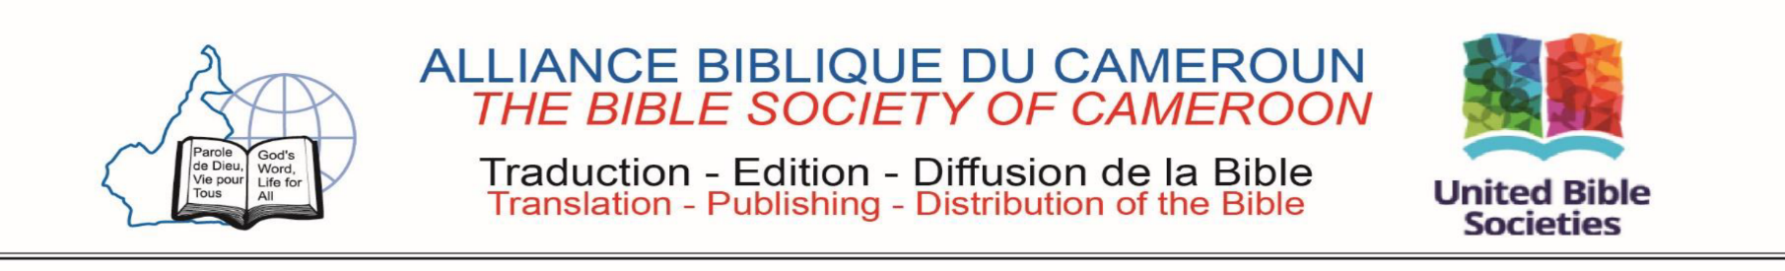
HEAD OFFICE Yaoundé March 31st, 2022
TRANSLATION HEAD OFFICE
TRANSLATION HEAD OFFICE
MUNGAKA TRANSLATION PROJECT REPORT FOR THE YEAR 2021
For the year 2021, the Mungaka Bible Revision's project has not been run as planned due the consequences of the COVID19 pandemic and security issues in the region. The plans made were respected in the majority of cases except for the training of revisers, publishing of a portion for the testing and little delays on the work of the translators. This report, organized on five main points, gives a brief of the work carried out during the year, presents the overall progress, highlights the difficulties encountered, makes suggestions and gives the planning for the year 2022.
STARTING: SEPTEMBER/03/2018
COMPLETION: DECEMBER/31/2032
GLOBAL PROGRESS: 27 %
2020 PROGRESS: 6%
- Activity Report for 2021
  - Books Drafting
This project continues to progress slowly due to the security issues and crisis in North-West region. The translation of the books of the New Testament continues. The overall progress has progressed this year from 09% to 21% but we are still delaying for around 4% on objectives.
  - Checking Manuscripts and publishing
In 2021, we had just one tracking and checking visit in Bamenda. We have also published the digital format of the Gospel of Mark for Android Devices available on Google Playstore.
  - Exegetical checking
For this year, we have had three checking made online by our Translation consultant Dr Samah Essosolim from Togo. The Books of Mark and Luke were checked and are ready now for printing and distributing.
  - Translators and Reviewers Training
The training of translators took place online and according to the participants, it was a success. The team has attended two times to the United Bible Society translators training organized also online.
- Progressing
Regarding the overall progress of the project, we went from 21% to 27% of the total progress rate. The following table provides a summary of the overall condition of the books as of December 31, 2021:

Not Started | 1st Draft | 2nd Draft | 3rd Draft | 4th (ready for publishing)
Genesis, Exodus, Leviticus, Numbers, Deutoronomy, Joshua, Judges Ruth, 1st 2nd Samuel, 1st 2nd Kings, 1st,2nd Chronicles, Ezra, Nehemiah, Esther, Job, Psalms, Proverbs, Ecclesiastes, Song of Solomon, Isaiah, Jeremiah, Lamentations, Ezekiel, Daniel, Hosea, Joel, Amos, Obadiah Jonah Micah, Nahum, Habakkuk, Zephaniah, Haggai Zechariah, Malachi, Tobit, Judith, Esther Grec, Wisdom, Siracide, Baruch, 1st, 2nd Maccabee, |  |  | John, Act, Romans,  1st, 2ndCorinthians,  Galatians, Ephesians, Philipians, Colossians,  1st, 2nd Thessalonians, 1st, 2nd Timothy,  Titus, Philemon, Hebrews, James, 1st  2nd Peter 1st 2nd 3rd John Jude, Jude, Revelation | Matthew, Mark, Luke
21 Livres | 30 Livres | 0 Livre | 13 Livres | 2 Livres
If this rate of progress is maintained for the years to come, we can end of the project in 2030 instead of 2033 as illustrated on the progress chart below:
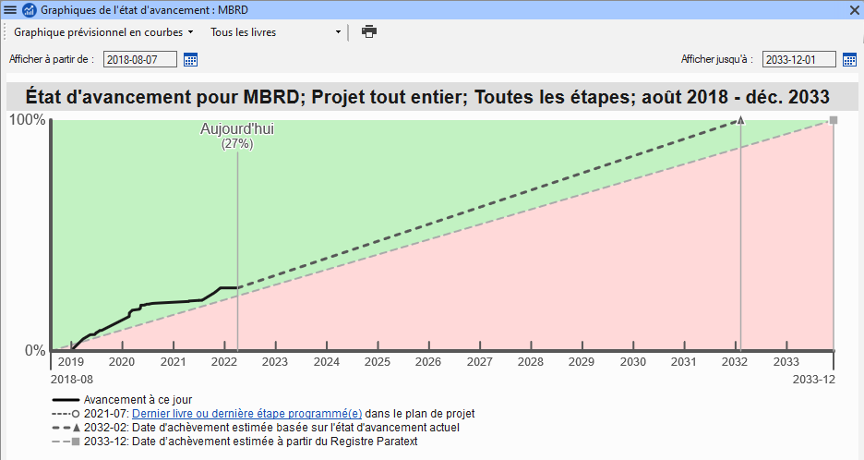
- Difficulties encountered
Among the difficulties encountered we can mention:
The situation of crisis in the North-West region which doesn't allow the translators to work normally and affect trainings and checkings;
The untimely power cuts which considerably slow down the work of translators;
The health matters that affect translators and Their families;
The lack of printing and distribution of Matthew’s book, which is necessary for the testing of the translation.
Lack of funding: the project is unfunded since 2019 due to financial crisis and Covid19 consequences.
- Suggestions
We suggest that:
- Something should be done as buying a generator to avoid stopping of the work because of power cuts;
- Look for possibilities to organize reviewers training even online;
- To Print and distribute the gospel of Matthew for testing and literacy;
- Planning for 2021
Organizing the reviewers training from February 25th to 27th 2021;
Translation of the following books in the table by the translators and reviewers:
- CONCLUSION
We give thanks to Almighty God for the work carried out during this year on this project. We would like to express our gratitude to the Director General of the Bible society of Cameroon for all efforts despite the funding difficulties allowing us to run activities and for providing a translation consultant to this project. Our thanks also go to the Mungaka’s Bible Translation Committee for their efforts to support this project. We cannot close this report without sending a call for prayer for peace and Security in North-West and South-West regions of our country and for God's providence for to allow us run this project up the end.

